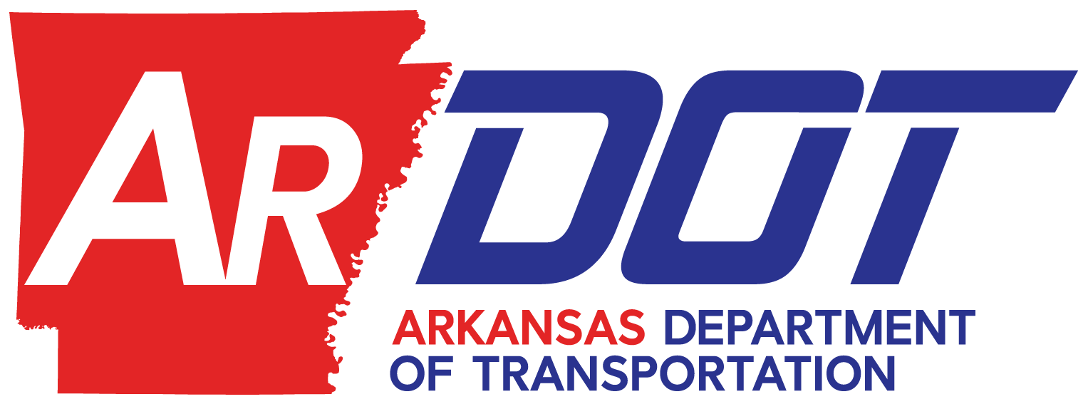

SECTION 5310 VEHICLE INVENTORY CONTROL FORM

AGENCY NAME:________________________________________________________________

VEHICLE DESCRIPTION: ________________________________________________________

VIN NUMBER: ____________________ FTA NUMBER: ______

TOTAL COST: $_________ FEDERAL (80%) MATCH: $_________ LOCAL (20%) MATCH: $_______

PURCHASE/PICKUP DATE: _____________ IN-SERVICE DATE: _____________

FTA PURCHASE ORDER NO: __________ ARDOT JOB NO: _______

FTA ACTIVITY CODE: ___________________________ FAIN NO: _____________________

CONDITION AT TIME OF PURCHASE: EXCELLENT ( X ) FAIR ( ) POOR ( )

-----------------------------------------------------------------------------------------------------------------------------------------------
* ATTACH your Public Notice (photocopy is acceptable) that was used of at least five (5) days prior to sale as required in either a newspaper of general circulation in the area where the vehicle is located, as a post on your website, or on your social media account(s).

* DISPOSAL DATE: __________________________________________________________

* SOLD TO: ________________________________________________________________

* SALE PRICE: ______________________________________________________________

Note: If sale proceeds exceed $5,000 per vehicle, the Federal share (80%) of the proceeds must be
returned to ARDOT according to FTA guidelines (unless prior approval to use proceeds to offset
the cost of a like-kind vehicle is agreed upon with ARDOT).

* FAIR MARKET VALUE: (STRAIGHT LINE DREPRECIATION) ________________________________

* REMARKS: ____________________________________________________________________

_____________________________________________________________________________________________________________

_____________________________________________________________________________________________________________

_____________________________________________________________________________________________________________

Signature: ___________________________________________________ Date: ____________________

REVISED 01/23/2020:TPP:PTP:dlc

UPON VEHICLE DISPOSAL (SOLD, AUCTIONED, ETC.), AGENCY IS REQUIRED TO COMPLETE FIELDS MARKED WITH AN ASTERICK ( * ) AND RETURN FORM TO: ARDOT – PUBLIC TRANSPORTATION PROGRAMS SECTION, P.O. BOX 2261, LITTLE ROCK, AR 72203-2261

